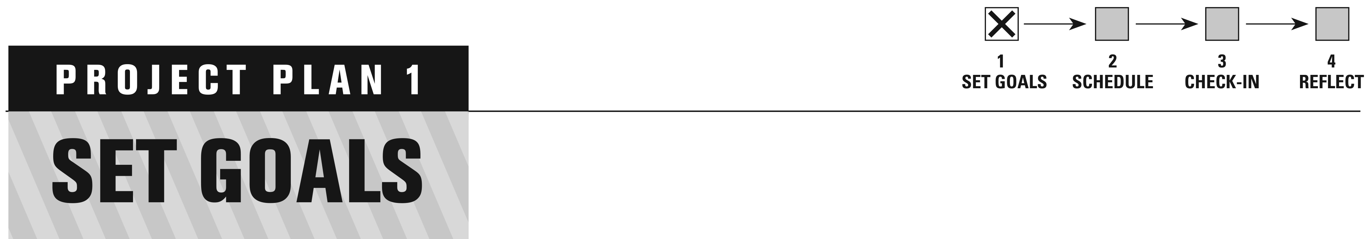

INSTRUCTIONS

In Part 1 of the Project Plan, you will outline your overall goals, resources, constraints, and assumptions to help you envision your final project.

Goals explain what will be achieved by the end of Future City. Setting goals will help you to determine what you want the outcome of the project to look like. Goals help you answer the question, “How do I know when I’m done?”

Once you have a general vision of your project, make sure your project goals are realistic and attainable. This can be done by identifying available resources, constraints, and assumptions.



Think About It

Goals can be wide ranging:

• How do you want to work as a team?

• What would you like to achieve with each deliverable?

• How could you apply the engineering design process to your project?

• What other goals are important to your team?

Visit the DEFINE stage of Leading Your Team (**futurecity.org**) to learn more about setting goals.



FUTURE CITY TEAM NAME:

ORGANIZATION:

EDUCATOR:

TEAM GOALS

The first goal is listed for you. Feel free to list more than four goals!

1. Our team will successfully create a futuristic waste management system for our future city.

2.

3.

4.

**Brainstorm possible resources, constraints, and assumptions for your project.**

|  |  |
| --- | --- |
| **Resources**  **THINK ABOUT IT**   * What resources are available through your school, home, and community? * What skills do team members and your mentor have? * Who can you call on for support? | |
| List the things that you might use as you research, design, and create your city.  These could include money, time, tradable goods, and services you own or can get for free. |  |
| **Constraints**  **THINK ABOUT IT**   * What might get in the way of you completing your project: - Busy schedules? - Size of group? - Other things? * How could your team work around any constraints? | |
| List the things that limit what you can do in some way.  These could include technology, human resources, time, competition rules, and deliverable requirements. |  |
| **Assumptions**  **THINK ABOUT IT**   * How much time might you need for planning? * Will materials be easy or difficult to find? * In what ways will your team work well together? * Which parts of the project seem most challenging? | |
| List the things you believe to be true about your Future City project. |  |

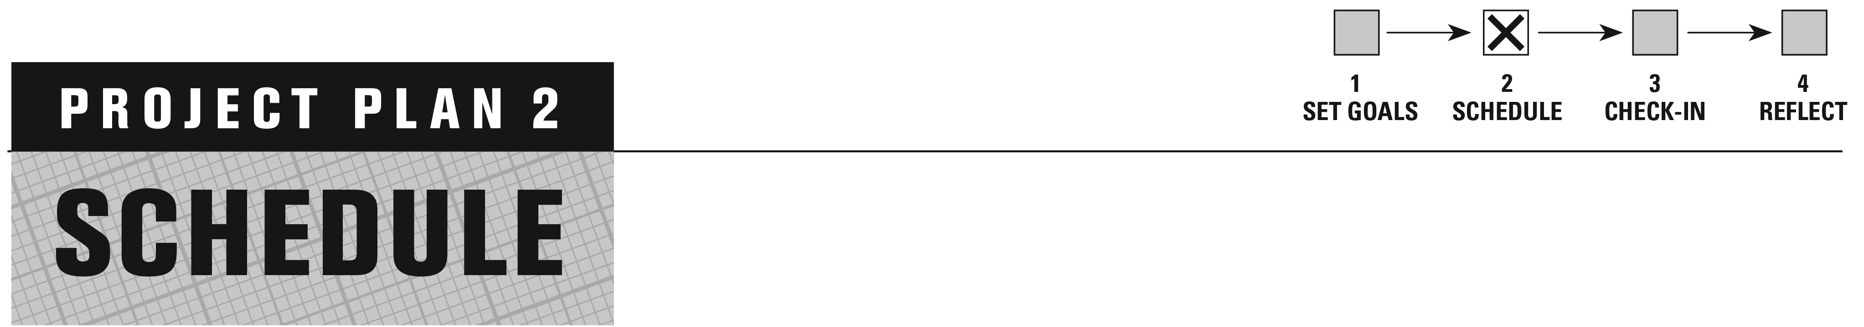

INSTRUCTIONS

In Part 2 of your Project Plan, you will make a schedule to help you complete each deliverable.

To create your schedule, you will identify what needs to be done and in what   
order. Follow the process outlined here or use your own.

Step 1: Establish Milestones & Tasks

Begin by brainstorming the milestones and tasks for each deliverable. Write the milestones and tasks for each deliverable on index cards or sticky notes. This   
will allow you to move them around later. (Use the template below as a guide   
or create your own.)

**Tip: Color Code Deliverables**

Choose a different color sticky note or index card to represent each deliverable. That way you can see the tasks for each deliverable and how the deliverables work together.

* **Milestones** are important points in the project’s timeline that help you determine whether your project is on schedule. Milestones are written as statements of what will have been accomplished.
* **Tasks** are the “to do” items you need to complete to accomplish each   
  milestone.

Think About It

What tasks support each milestone?

*For example, a milestone for the City Model is to complete the moving part. Tasks for building the moving part could be to research ideas, collect materials, and design and build the moving part.*

Schedule Card Template

Deliverable:

Milestone/Task:

Estimated Time to Complete:

Team Member(s):



Visit the PLAN stage of Leading Your Team (**futurecity.org**) to learn more about scheduling.

Step 2: Determine Sequence

Now it’s time to think about the order in which things should be done. Arrange the cards for each deliverable in a logical order.

• An **Independent Task** can be completed at any time and is not related to some other thing being done.

• A **Dependent Task** must be completed before the next one can begin.

Think About It

Does one task need to be completed before another one can begin?

*For example, before you can build the City Model, you first need to determine the scale.*

Step 3: Estimate Time

Think about how much time tasks will take and record the time on the cards. Keep in mind there are two types of time:

• **Work Time:** How long it will take a person to do the work.

• **Elapsed Time:** How long it takes for a task to be completed.

Think About It

How much work time and elapsed time would it take to glue trees to your city model?

*For example, it may take 30 minutes of work time for you to glue trees to your City Model, but it takes 24 hours (elapsed time) for the glue to dry.*

Step 4: Assign Roles

Next decide who will get the work done. Assign team members to be responsible for each task and record their names on the cards.

Think About It

• What are the interests and skills of each team member?

• How will you divide the work?

• Is work distributed fairly among team members?

Step 5: Make a Schedule

Now it’s time to transfer your cards to an actual schedule and assign dates. One way is to attach your cards to a timeline or large wall calendar.

**Keep in mind** that things will change along the way—be sure to review and revise your schedule as needed.

Show Us Your Style!

An image of your schedule is part of your Project Plan deliverable. What does your schedule look like?

Did you:

- make a large wall calendar;

- use a shared online calendar; or

- schedule your project mostly through text messages?

Show the process you used by inserting a photo, screen shot, or drawing in the Team Schedule sheet on the next page.



FUTURE CITY TEAM NAME:

ORGANIZATION:

EDUCATOR:

|  |
| --- |
| TEAM SCHEDULE |

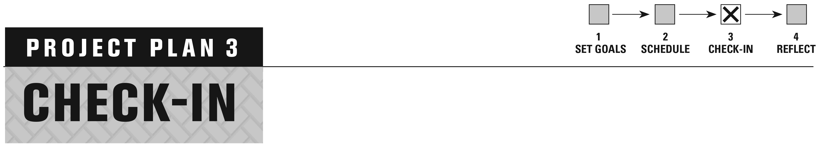

INSTRUCTIONS

In Part 3 of your Project Plan, you will conduct check-in sessions to help you monitor your project’s progress and ensure that you meet your goals.

Regular check-ins are a great way to communicate with your team. These meetings can be simple and quick—just be sure to do them often!

Make copies of the Check-In Report template and use them to update all   
project stakeholders (team members, educator, mentor) on the status of   
your Future City project.

Tip: Before Each Check-In:

* Review your schedule and the requirements for each deliverable.

**After Each Check-In:**

* Make changes to your schedule as needed.

Show Us Your Style!

**One Check-in Report is part of your Project Plan deliverable**

Submit one report that illustrates an important point in your project, such as when you solved a problem, made a critical revision, or reached a major milestone.



Visit the DO stage of Leading Your Team (**futurecity.org**) to learn more about check-ins.



FUTURE CITY TEAM NAME:

ORGANIZATION:

EDUCATOR:

Team Check-In Report

Date:

Team Members:

|  |  |
| --- | --- |
| What have you completed recently? |  |
| What are you working on now? |  |
| When do you think the current task will be done? |  |
| What do you need to keep your work on track with good quality? |  |
| Additional Notes |  |

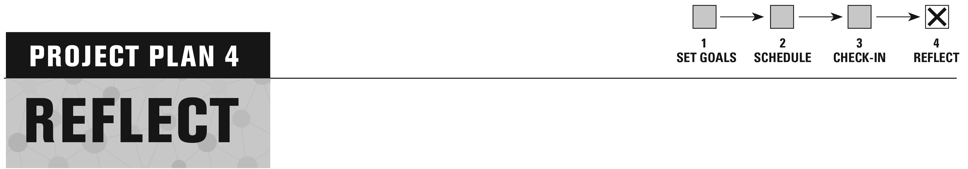

INSTRUCTIONS

In Part 4 of your Project Plan, you will reflect on lessons learned to help make your next projects easier.

Now that your hours of hard work have paid off, it’s time review what you did and how you did it.

Working as a team, record your responses to the questions on the next page.

Tip: Prepare for the Competition

Judges ask questions just like these. Reviewing your project and answering these   
questions are a great way to prepare for your presentation!



Visit the REVIEW stage of Leading Your Team (**futurecity.org**) to learn more about reflection.



FUTURE CITY TEAM NAME:

ORGANIZATION:

EDUCATOR:

TEAM REFLECTION

1. Look back at your original project goals from the Define stage. Did your team fully meet your stated goals for the project? Were there some goals that were met more completely than others?

2. Look back at your original ideas for your city. Did any of the ideas change as you went through the process of creating your final city? Describe one way your city changed and why.

3. Consider your schedule and process. What were some of the major challenges to meeting your deadlines, and how did you overcome those challenges?

4. Consider your team. How well did your Future City team work together? What do you know now about being part of a team that you didn’t know before?

5. What was the most helpful piece of advice you received from your mentor or teacher as you worked on your Future City project?

6. What was the most valuable experience you gained from the Future City Competition?